

MUFFAKHAM JAH COLLEGE OF ENGINEERING AND TECHNOLOGY

Banjara Hills, Hyderabad.

**PROJECT REPORT**

**ON**

**“SMART SHOPPING CHART ”**

Submitted by:

**Tech Team SIG**

**CONTENTS**

1. Abstract
2. Introduction
3. Platform Used
4. Project Description
5. Advantages
6. Future Scope
7. Conclusion
8. References
9. **ABSTRACT:**

Customers who need to purchase different products in supermarkets needs lots of time and patience in coordinating among them self for successful shopping. We need to address this problem by efficiently using our technologies. In the advancement of technologies, the world is getting automated in many aspects. In this Paper, we depict reasonable and cost-effective Smart Shopping Cart utilizing **Internet of Things** innovations.

**2. INTRODUCTION:**

The Automated **Shopping Cart**, “**Smart Cart**”, is an innovative consumer purchasing product that is designed to help shoppers fast-track their **shopping** experience Shoppers are allowed to use their personal credit/debit card or a store issued card to activate the **cart**.

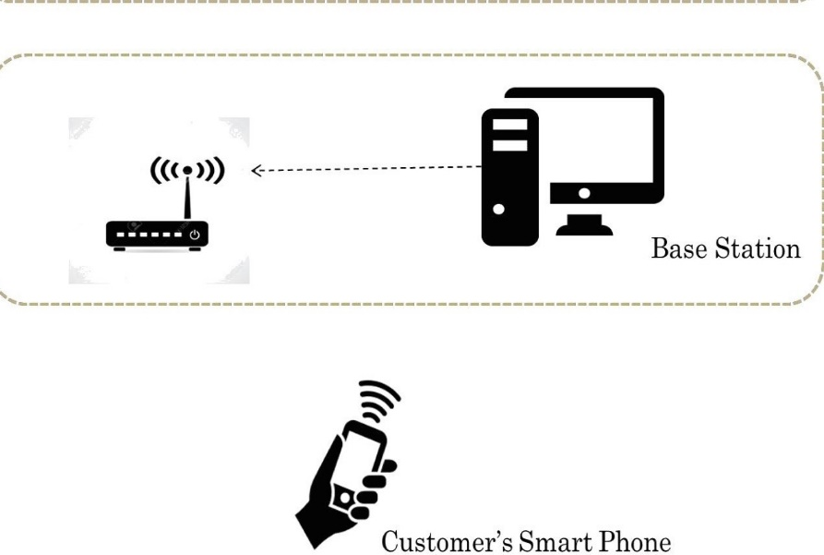

**3 .PLATFORM USED:**

**MIT App Inventor:** is a web application integrated development environment originally provided by Google, and now maintained by the Massachusetts Institute of Technology (MIT). It allows newcomers to computer programming to create application software for two operating systems: Android and iOS

It uses a graphical user interface very similar to the programming languages

**4. PROJECT DESCRIPTION:**

Every Shopping Cart is equipped with a QR Code scanner, a camera, a weight sensor, a small computer for local processing and a display device (to save cost, customer’s Smartphone will be used as display).

She /he once they can scan the products one by one with the QR Code scanner present at the cart and keep adding them to the cart. In order to handle all the cases of mistake/dishonesty, the design includes the use of weight sensor at the cart.

Once the customer finishes shopping, she/he then proceeds to the payment counter to pay the bill amount.

Its stores the data in Google spreadsheets and sends the bill for both consumer and seller through email

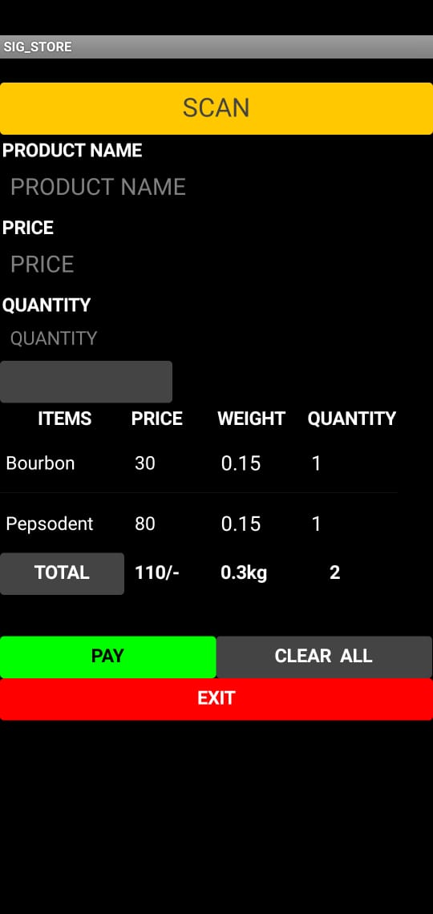

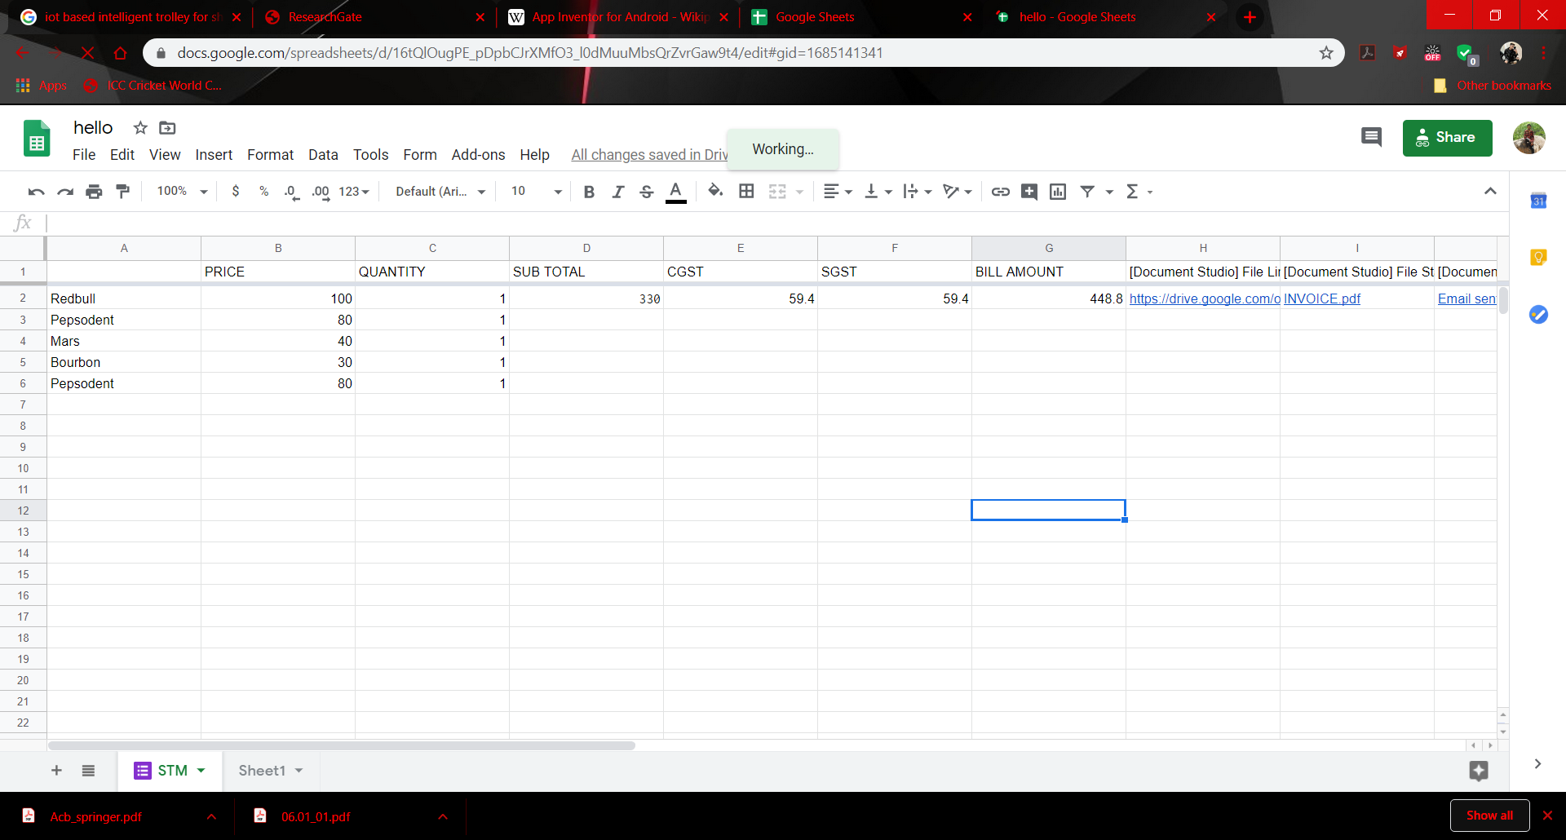

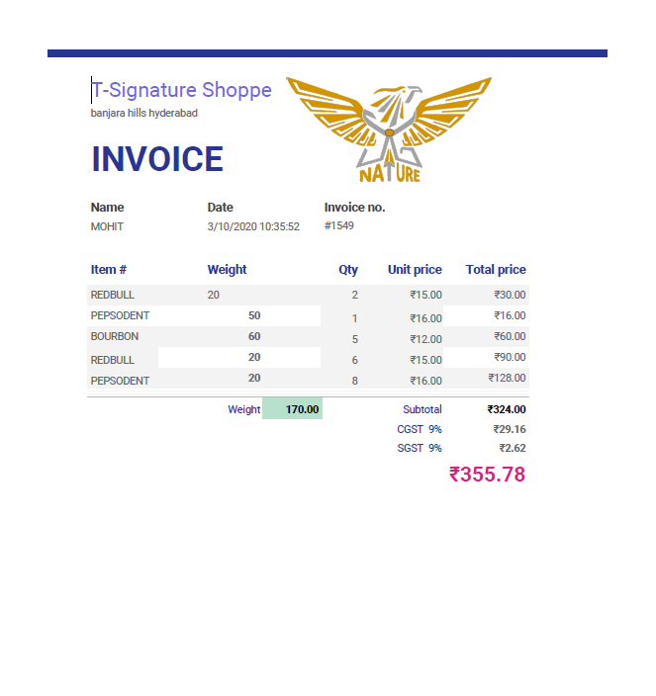

1. **ADVANTAGES:**

* Improve the shopping experience for all the customers of the store
* Increase efficiency of the exit process
* Eliminates a long waiting queues at the exit counter
* Safer shopping
* Convenient shopping
* Easy payments

1. **Future Scope:**

* One of the common issues that clients face in the existing system such as unable to find the items in the inventory or employee for any help.
* The application will help the clients to find items at the right inventory by providing the information about the items in the list along with a route map of the super market thereby providing new experience to the clients
* This will also have the history of the items bought by the client. This will enable client to use the data for next purchase. The supermarket can understand the trend and hence stock the inventory or promote offers accordingly.

1. **CONCLUSION:**

The Internet of Things is one such technology that connects various objects in a network and is a milestone in the era of the smart world. The smart shopping cart features these technology enabling users to shop efficiently.

This smart shopping cart is implemented in such a way that it allows the customer to scan the item that he/she wants to purchase and automatically updates the bill thus preventing long queues at the checkout.

1. **REFERENCES:**

<https://www.researchgate.net/publication/324271203_An_IOT_Based_Smart_Shopping_Cart_for_Smart_Shopping/link/5baa0867299bf13e604a7cb0/download>